LAB 2
Problem 61 – Household Carbon Footprint & Target Tracker
Name: Siddu Sanganna Shirasagi
SRN: PES1UG25CS846

Epics and User Stories
Epic ID | Epic | Stories
HCFTT-1 | Monthly Consumption & CO₂e Calculation | HCFTT-4 Record Monthly Consumption; HCFTT-5 Calculate Monthly CO₂e
HCFTT-2 | Emissions History & Reduction Target | HCFTT-6 View Emissions History; HCFTT-7 Set Reduction Target; HCFTT-8 Track Target Progress
HCFTT-3 | Sustainability Coach Monitoring | HCFTT-9 Review Household Progress

Priorities and Story Points
Jira ID | User Story | Priority | Points
HCFTT-4 | Record Monthly Consumption | High | 5
HCFTT-5 | Calculate Monthly CO₂e | High | 8
HCFTT-6 | View Emissions History | Medium | 5
HCFTT-7 | Set Reduction Target | High | 3
HCFTT-8 | Track Target Progress | High | 5
HCFTT-9 | Review Household Progress | Medium | 3

Screenshots

Jira Backlog – Epics + User Stories
The screenshot shows the Epic panel with all 3 Epics and the 6 User Stories with their associations.
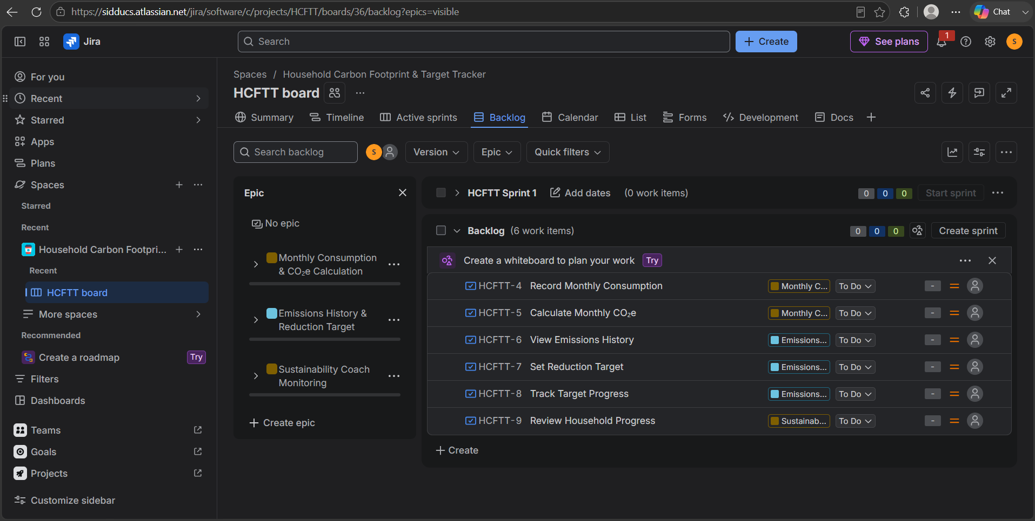

Story Point Assignments
The screenshot shows all 6 stories with their Story Point values and the 29-point total.
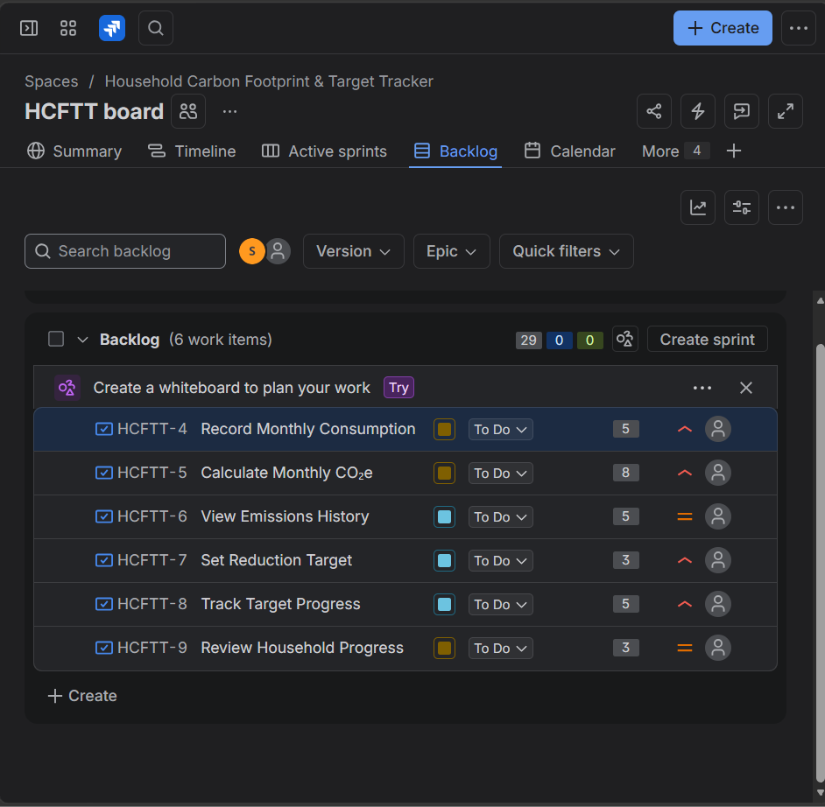

Sprint 1 Planning
The screenshot shows Sprint 1 with 4 work items totaling 21 points and the remaining backlog with 2 work items totaling 8 points.
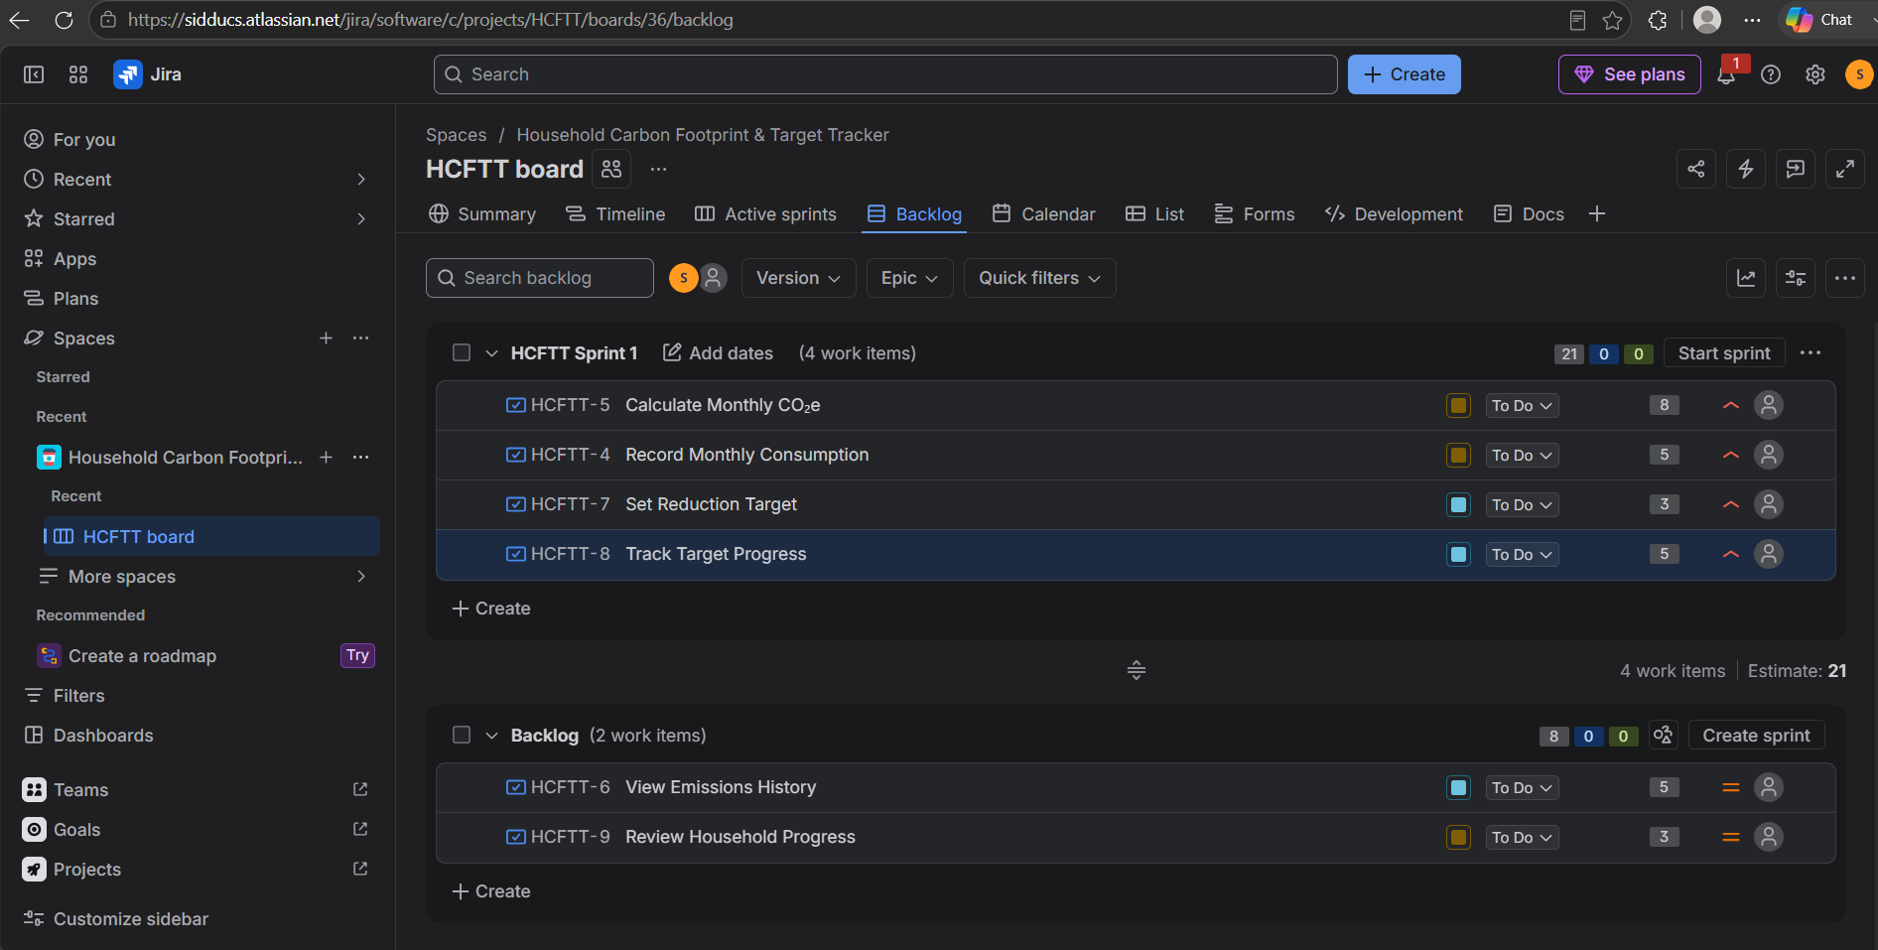

Active Sprint – Day 1
The screenshot shows the active Sprint 1 with 4 stories / 21 points, all initially in To Do.
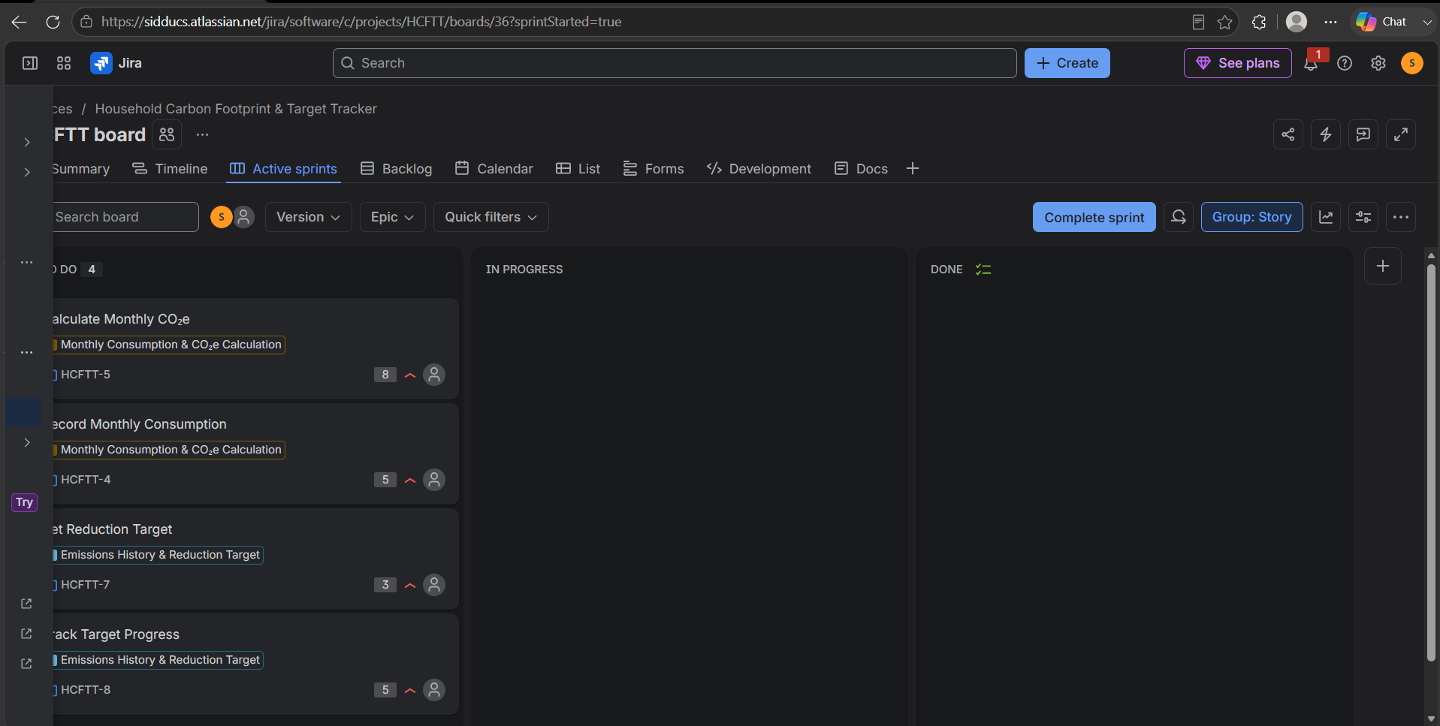

Sprint 1 – Day 2 Progres
The screenshot shows 2 stories in In Progress (13 points), 2 in To Do (8 points), and none Done.
